Jessica Miron
BME 598: Applied Programming
Homework 5
Part 2:
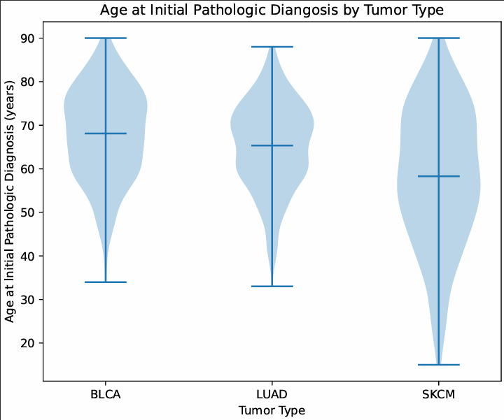
Part 3: Overall Survival Time by Gender
Male and female patients show very similar survival time distributions. Both categories show nearly identical means and a similar distribution shape with a bulbous area between zero and 2000 days before tapering off. Female patients had a wider range of survival time but male patients had a greater number between 3000 and 6000 days.
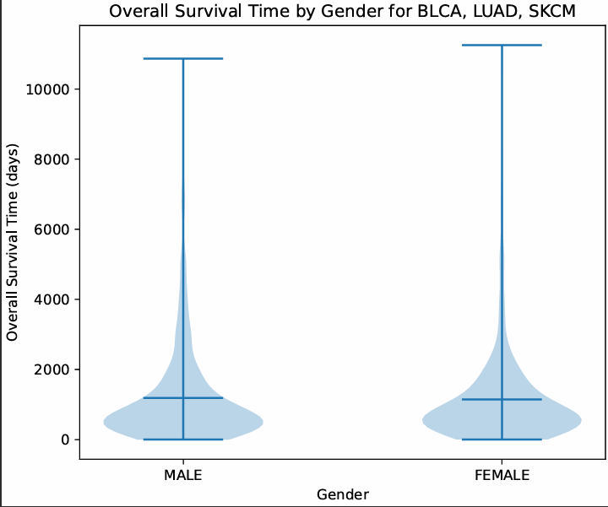
Part 4: Age at Initial Pathologic Diagnosis by Race for LUAD
The distribution shows that white patients have a wider distribution for age of diagnosis, but all races besides black or African American patients have very similar means. Comparing the distribution with the number of patients in each group, the white group has 393 patients while the next highest group, black or African American, has 53 patients. This corresponds to the white group having the widest distribution and narrow tails while the other groups have less spread and a lack of a narrow tail. More samples would be needed to fully identify the distribution of all the groups besides white.
